**Name = Kevin Mody**

**Lab Partner = Lisset Marin and Hayley Ormond**

**Date = 9/17/18**

**Lab #3 Projection Motion**

**Grade =**

**Lab #3 Projection Motion**

Objective:

The objective of this lab was to find the height, time and different velocities. We also need to stimulate our variable in the program called Interactive Physics (IP).

Theory:

1.*v*=*v*0​+*at*1

2.Δ*x*=(2*v*+*v*i​​)\**t*

3.Δ*x*=*v*i​*t*+1/2​*at*2

4.*v*^2=*v*i^2​+2*a*Δ*x*

Data:

Part 1

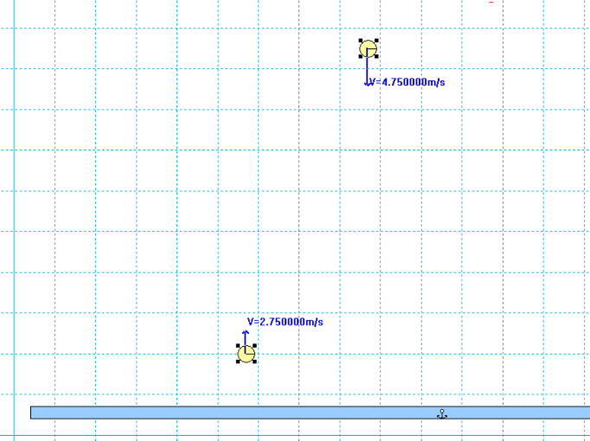

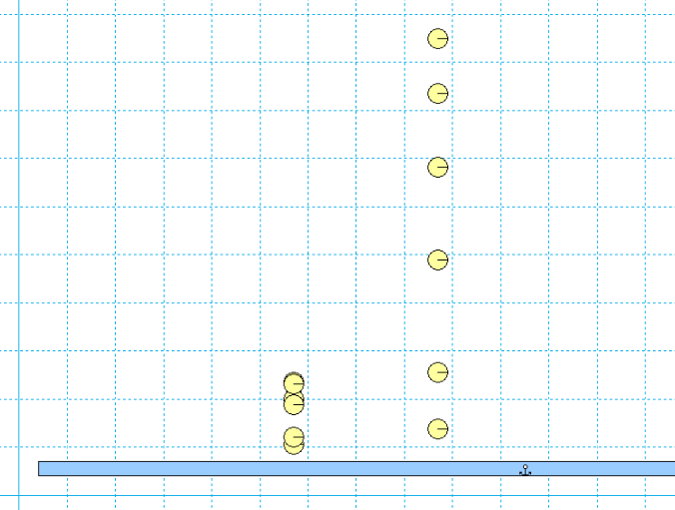

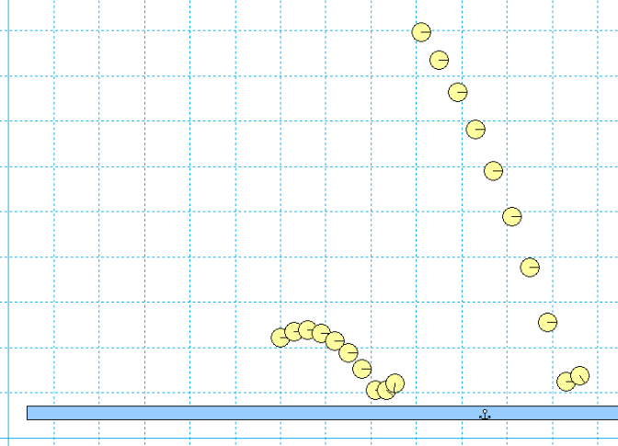

Part 2:

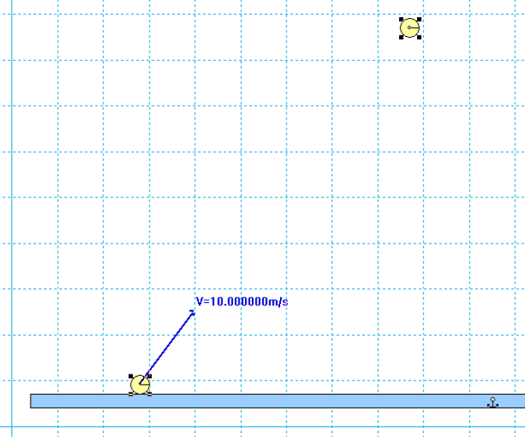

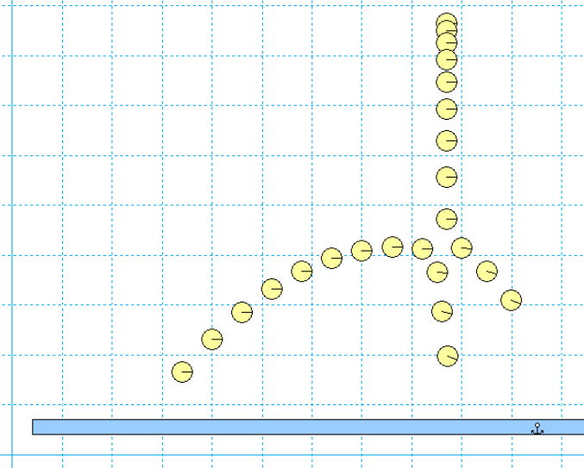

Procedure:

1. Part 1 A, B and C:

* Use the rectangle tool to create a floor and anchor it.
* Use the circle tool to create a small circle, drag it to some height above the floor, and give it some velocity in the y-direction (right click the circle to adjust its values); keep vx = 0 for now.
* Create a second circle at a different height.
* Calculate the necessary initial y-velocity so the two circles hit the floor at the same time.
* Give the second circle this initial y-velocity.
* Use the Windows ``Snipping Tool'' to take a screen shot of your initial conditions.
* Select both circles and click Windows Appearance and check ``Track outline''.
* Run the simulation until both circles hit the floor.
* Take another screenshot to show that your calculations were correct.
* Restart the simulation (clear the tracks by clicking World Erase Track).
* Give the circles some random (but reasonable) x-velocity to show they still hit the floor at the same time.
* Run the simulation and take another screenshot.

1. Part 2 A and B;

* Using similar techniques as in Part 1, design an experiment where a projectile collides with a freely falling object.
* Show relevant screen shots

Calculations:

Attached in Calculations.pdf

Results:

Part 1:

1. Ball 2:

|  |  |
| --- | --- |
| X | 1.5m |
| Y | 6.4m |
| Vy | 3m/s |
| A | -9.81m/s^2 |
| T | 1.49s |
| Vx | 3m/s |

1. Ball 1:

|  |  |
| --- | --- |
| X | 4.5m |
| Y | 10.5m |
| A | -9.81m/s^2 |
| T | 1.49s |
| Vy | .201m/s |
| Vx | 4m/s |

Part 2:

1. Ball 1:

|  |  |
| --- | --- |
| X | 11.5m |
| Y | 8.5m |
| Vx | 14^2m/s |
| A | -9.81m/s^2 |

1. Ball 2:

|  |  |
| --- | --- |
| X | 2.50m |
| Y | 8.5m |
| Vy | 9m/s |
| A | -9.81m/s^2 |

|  |  |
| --- | --- |
| |V| | 16.64 |

Analysis:

In the IP, the number were accurate and it useful in the real world. The calculations and stimulation were easy. We think physicians should more often this program.

Comments:

No comments.